

|  |
| --- |
|  |
| **Name: -** V D Panduranga Sai Guptha  **Section: -** B  Roll No: -AP21110010091  **DATA STRUCTURES LAB RECORD** |
| |  |  |  | | --- | --- | --- | | Data Structures | 2/26/22 | Lab record | |

**INDEX**

|  |  |  |  |  |
| --- | --- | --- | --- | --- |
| **EXPERIMENT  NUMBER:** | **EXPERIMENT NAME AND TOPIC** | **PAGE NUMBER** | **Google classroom**  **SUBMISSION**  **STATUS** | **REMARKS** |
| 01 | Conversion of infix expression to postfix expression (stacks) | 02 to 05 | completed |  |
| 02 | Evaluation of expressions (stacks) | 06 to 08 | completed |  |
| 03A | Implementation the following operations i.e., enqueue, dequeue and finding an element  in the following cases:  a. Linear Queue using arrays | 09 to 15 | completed |  |
| 03B | Implementation the following operations i.e., enqueue, dequeue and finding an element  in the following cases:  b. Circular queue arrays | 16 to 19 | completed |  |
| 04 | Create a singly linked list and perform the following operations:  a. Add an element at the end of the list b. Delete an element from the beginning of the list c. Find the middle element of the list | 20 to 25 | completed |  |
| 04B | Part-2 of Lab program 4 e. Priority queue singly linked list. f. Polynomial addition using linked list g. Sparse matrix operations using linked list | 26 to 36 | completed |  |
| 05 | Implementation of Binary tree traversals techniques: a. pre-order b. in-order, and c. post-order. | 37 to 39 | completed |  |
| 06 | implementation of AVL tree and its operations a. Insertion b. Deletion c. Traversing | 40 to 45 | Completed |  |
| 07 | Implementation of Graph traversals techniques: a. BFS b. DFS | 46 to 55 | pending |  |

**Lab Experiment number: - 01**

**Experiment Topic**: - **Conversion of infix expression to postfix expression (stacks)**

**AIM: -** Implementation of C language code to execute the program to convert infix expression to postfix expression by using arrays concept and with the help of stacks (Data Structures).

**OBJECTIVES: -** By doing this experiment students finally understand,

1. how to write efficient algorithm to a specific problem.
2. How to use arrays in data structures.
3. Concept of stacks and evaluation of expression problems.
4. How to frame prefix expressions and postfix expressions manually.
5. Concept of prefix and infix and its mechanics and properties.

**CONDITIONS: -**

Conditions to follow while writing code for experiment 01: -

1. Arrays should be named different.
2. Only one element can be popped once.
3. Array should take input alphanumeric.

**ALGORITHM: -**

Step 1: -start

Step 2: - input Arrays, top=-1

Step 3: - check stack is empty or not

Step 4: - push operator to stack

Step 5: - check for operands

Step 6: - pop operators according to priority

Step 7: - If the precedence of the scanned operator is greater than the precedence of the operator in the stack (or the stack is empty or the stack contains a ‘(‘), push it

Step 7: - copy popped operators and operands to another stack

Step 8: - print the stack which contains popped elements or expression elements

Step 9: -stop

**PROGRAM: -**

**File name**: - inpostfix.c

**Google Drive link**: -<https://drive.google.com/file/d/1kFV3WNH1Qn3ovC20GkVqyqJpF3_DNF9v/view?usp=sharing>

**Implementation: -**

#include<stdio.h>

#include<string.h>

#include<math.h>

#define BLANK ' ' //blank space is initialized to BLANK

#define TAB '\t’

#define MAX 50

char prefix[MAX];

char stack1[MAX][MAX];

int top;

char *pop() //function to pop the element from stack

{

if(top == -1 )

{

printf("\nStack underflow \n");

exit(2);

}

else

return (stack1[top--]);

}

void push(char *str) // function to insert element into the stack

{

if(top > MAX)

{

printf("\nStack overflow\n");

exit(1);

}

else

{

top=top+1; //incrementing top before progress

strcpy( stack1[top], str);//copying string

}

}

int isempty() //function to check whether the stack is empty or not

{

if(top==-1)

return 1;

else

return 0;

}

int white_space(char symbol) //function check whether the element tab or black space etc

{

if(symbol==BLANK || symbol==TAB || symbol=='\0')

return 1;

else

return 0;

}

void prefix_to_postfix() //function to convert scanned expression to postfix

{

int i;

char operand1[MAX], operand2[MAX];

char symbol;

char temp[2];

char strin[MAX];

for(i=strlen(prefix)-1;i>=0;i--)

{

symbol=prefix[i];

temp[0]=symbol;

temp[1]='\0';

if(!white_space(symbol))

{

switch(symbol)

{

case '+':

case '-':

case '*':

case '/':

case '%':

case '^':

strcpy(operand1,pop());

strcpy(operand2,pop());

strcpy(strin,operand1);

strcat(strin,operand2);

strcat(strin,temp);

push(strin);

break;

default:

push(temp);

}

}

}

printf("\nPostfix Expression :: ");

puts(stack1[0]);

}

int main()

{

top = -1;

printf("Enter Prefix Expression : ");

gets(prefix); //reading the input

prefix_to_postfix();

}

**OUTPUT: -**

**Test case :1 Test case :2**

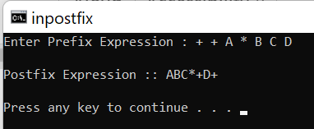 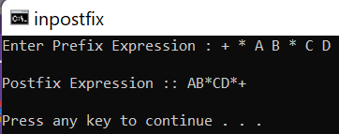

**Test case :3 Test case :4**

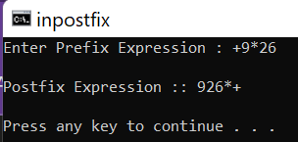 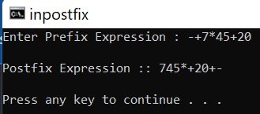

**PROBLEM FACED: -**

1. While coding the problem confused in taking number of arrays.
2. Even deciding the priority return values got confused.
3. In runtime it showing popup message like some error but can be executable.
4. Issues in compile time due to syntax error more than 3 times in testing level.

**CONCLUSION: -**

1. This experiment allowed me to think in efficient manner.
2. I was improved my programming skills.
3. Learned how to use stacks with arrays.
4. Completely understood the concept of stacks.
5. Learned the mechanics of infix and postfix expression.
6. Learned how to convert infix to postfix manually.

**Lab Experiment number: - 02**

**Experiment Topic**: - **Evaluation of expressions (stacks)**

**AIM: -** Implementation of C language code to execute the program to evaluation of expressions by using arrays concept and with the help of stacks.

**OBJECTIVES: -** By the end of this assignment, we will be able to

1. write efficient algorithm to a specific problem.
2. Use arrays in data structures.
3. Concept of stacks and evaluation of expression problems and results after solving expressions.
4. Framing prefix expressions and postfix expressions and evaluation of expression manually.

**CONDITIONS: -**

Conditions to follow while writing code for experiment 02: -

1. Arrays should be named different.
2. Code should take input postfix expression.
3. Array should take input alphanumeric (digits and characters).
4. Maintain less runtime.
5. Operands Priority management

**ALGORITHM: -**

Step 1: -start

Step 2: -input expression

Step 3: -initialize top= -1

Step 3: -functions to operate stacks

Step 4: -check the scanned array not to be empty

Step 5: - to check if the passed character is a digit or not

Step 5: -conditions to evaluation

Step 6: -add all the pop() elements

Step 7: -print sum of popped elements

Step 8: -end

**PROGRAM**: -

**File name: -**preevalue.c

**Google drive link: -** <https://drive.google.com/file/d/1iikfJfbvVD-vwhQVByuQi24fjYXn90bx/view?usp=sharing>

**Implementation: -**

#include<stdio.h>

int stack1[20];

int top = -1;

void push(int x) // function to insert element into the stack

{

stack1[++top] = x;

}

int pop()////function to pop the element from stack

{

return stack1[top--];

}

int main()

{

char exp[20];

char *e;

int n1,n2,n3,num;

printf("Enter the expression :: ");

scanf("%s",exp);

e = exp;

while(*e != '\0')

{

if(isdigit(*e)) //checks entered elements are numbers or digits or characters

{

num = *e - 48; // ascii code transformation

push(num);

}

else

{

n1 = pop();

n2 = pop();

switch(*e) // operands declaration

{

case '+':

{

n3 = n1 + n2;

break;

}

case '-':

{

n3 = n2 - n1;

break;

}

case '*':

{

n3 = n1 * n2;

break;

}

case '/':

{

n3 = n2 / n1;

break;

}

}

push(n3);

}

e++;

}

printf("\nThe result of expression %s = %d\n\n",exp,pop()); //prints output sum

return 0;

}

**OUTPUT: -**

**Test case 1: -**

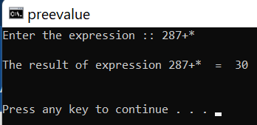

**Test case 2: -**

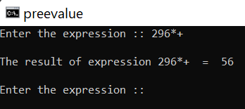

**Test case 3: -**

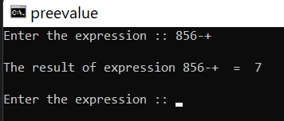

**PROBLEM FACED: -**

1. While coding confused in taking number of arrays.
2. Even deciding the priority return values I were got confused.
3. In runtime it showing popup message error but can be executable.
4. Issues in compile time due to syntax error more than 8 times in testing level.

**CONCLUSION: -**

1. This experiment allowed me to think in efficient manner.
2. I improved my programming skills.
3. Learned using stacks with arrays.
4. Completely understood the concept of stacks in evaluation of expression values.
5. Learned the mechanics of infix and postfix expression and evaluation of expression.
6. Learned how to evaluate the expressions manually.

**Lab Experiment number: - 03A**

**Experiment Topic**: - Implementation the following operations i.e., enqueue, dequeue and finding an element

in the following cases:

a. Linear Queue using arrays or

b. Circular queue arrays

**Experiment 03A on linear queue using arrays**

**AIM: -** Implementation of c code to perform operations on queue data structure like inserting elements to queue and deleting the elements from queue and checking the first element in queue.

**OBJECTIVES: -** By the end of this, we will be able to know how

1. write efficient algorithm to linear queue operations.
2. Use arrays in queue data structures.
3. Concept of queue and its operations performs in a code.
4. Improves coding experience.

**CONDITIONS: -**

Conditions to follow while writing code for experiment 03A: -

1. Arrays should be named different.
2. Two pointers must be used.
3. Basic mathematical tricks should be used.
4. Memory management should be done.
5. All conditions of queue should be satisfied by this experiment.
6. Initialization of function should be done in header file. (choice)

**ALGORITHM: -**

**Algorithm for main function :**

Step 1: start

Step 2: initialize Maximum elements

Step 3: initialization of queue array and front=0 and rear =-1

Step 4: include header file “queue.h” (user defined)

Step 5: input elements to insert in queue

Step 6: delete elements in queue

Step 7: prints elements which are deleted

Step 8: stop

**HEADER FILE(queue.h) FUNCTIONS ALGORITHM**

**Algorithm for insert (int data) function: -**

Step 1: start

Step 2: check if rear pointer is equal to one less than MAXIMUM elements if yes

Step 3: prints queue is full

Step 4: else increment rear pointer by one and assignment data variable

Step 5: stop

**Algorithm for delete() function:**

Step 1: start

Step 2: check if rear is equal to -1 print queue is empty

Step 3: else print the front element of the queue array

Step 4: initialize front element of queue array to data element

Step 5: increment front pointer by one

Step 6: check if front pointer is greater than rear pointer if yes then reinitialize both pointers to -1

Step 6: return data element

Step 7: stop

**Algorithm for first( ) function:(checks the first element of queue and prints it in output )**

Step 1: start

Step 2: initialize data variable to front pointed element in queue array

Step 3: prints data variable

Step 4: stop

**Algorithm for prints(int arr[]) function :**

Step 1: check if rear pointer is -1 if yes print stack is empty

Step 2: else print array elements by increment loop with condition i=front and i<rear

Step 3: stop

**PROGRAM**: -

**Folder name:** queueoperations

**C File name: -**queueoperations.c

**Header file name:** queue.h

**Google drive link:** <https://drive.google.com/drive/folders/1RGpikQkaPbyxsKOiaHoFsJC4fxouCXda?usp=sharing>

**Implementation: -**

**Queueoperations.c**

#include<stdio.h>

#define MAX 5

int queue[MAX];

int front=0;

int rear=-1;

#include"queue.h"

void main()

{

printf("\t!!!queue opereations!!!");

insert(23);

insert(34);

insert(78);

insert(26);

insert(89);

printf("\n");

first();

printf("\n");

delete();

delete();

printf("\n");

first();

printf("\n");

prints();

insert(89);

}

**Header file:**

**Queue.h:**

void insert(int data)

{

if(rear==MAX-1) //condition for checing queue is full or not

printf("\nqueue isfull ");

else

{

queue[++rear]=data; //post increment rear ptr and assigning to data

printf("\ninsert-->%d",data);

}

}

void delete()

{

if(rear==-1) //checking queue is empty or !

{

printf("\nqueue is empty");

}

else

{

int data;

printf("\nremoved data :%d",queue[front]);

queue[front]=data; //first element in the array is assigned to data

front++;

if(front>rear)

front=rear=-1;//reinitializing 2 ptr to -1

}

}

void first()

{

int data=queue[front];//printing first element in tne aray

printf("\nfirst element:%d",data);

}

void prints()

{

if(rear==-1)

printf("\nstack is empty");

else

{

int i;

for(i=front;i<=rear;i++){

printf("\nqueue[i]=%d",queue[i]);

}

}

}

OUTPUT:  
test case 1:

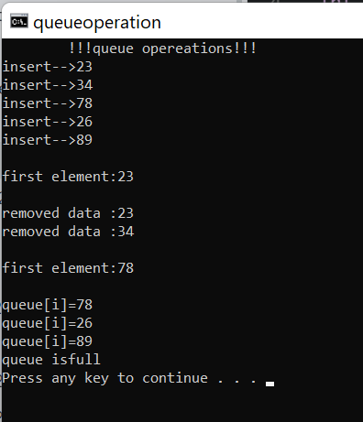

**Input inserting elements into the program and deleting entire queue and showing empty queue program.**

**Drive link: -** <https://drive.google.com/file/d/1XDx9OgvozwN-1jsL8iFQ7exzdE_uKGJb/view?usp=sharing>

**Inputqueue.c**

#include<stdio.h>

int queue[12];

int front=0;

int rear=-1;

int MAX;

int arr[12];

#include"queue.h"

int main()

{

printf("!!!! queue operations in input method !!!!\n\n");

printf("enter number of elements in queue :");

scanf("%d",&MAX);

printf("\nenter the elements:\n");

for(int i=0;i<MAX;i++)

{

int data;

printf("\nenter queue[%d]:",i);

scanf("%d",&data);

insert(data);

}

prints(queue);

printf("\n");

for(int i=0;i<MAX;i++)

{

arr[i]=queue[front];

delete();

}

printf("\narray containg deleted elements");

for(int i=0;i<MAX;i++)

{

printf("\narr[%d]=%d",i,arr[i]);}

printf("\n\nafter deletion:\n");

prints(queue);

}

**OUTPUT:**

**Test case 01:**

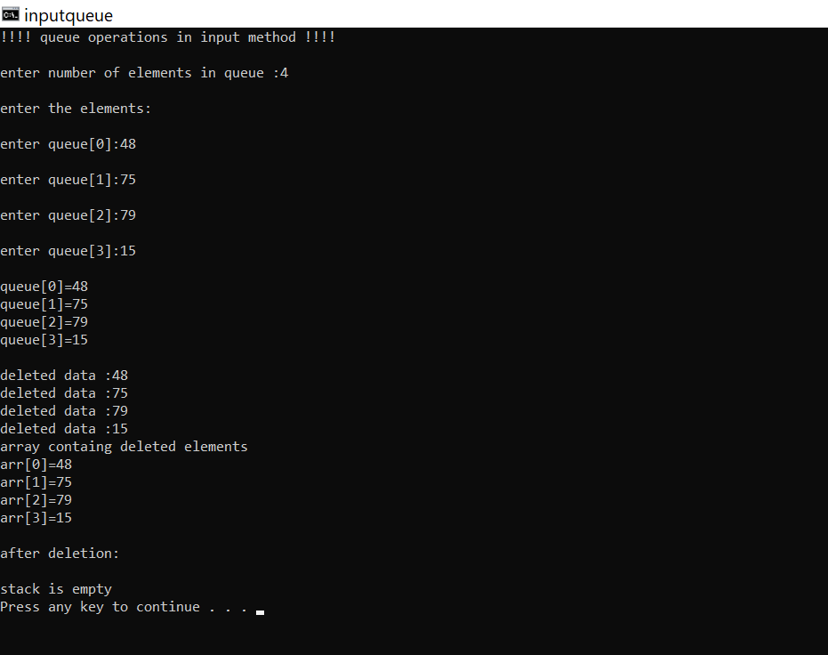

**PROBLEM FACED: -**

1. While writing algorithm I faced some problem.
2. While compile time few issues with function word terminology.
3. While runtime I faced issue in minimizing the run time.
4. Failed in dynamic memory allocation.
5. Failed in collecting deleting elements to another array.

**CONCLUSION: -**

1. This experiment helped me to know where my skills are.
2. Learned queue concept and using of it.
3. Learned writing code with good indentation.
4. Learned implementation of header files and learned how to store queues operations in header file.
5. This experiment helped me to improve my minimum coding speed.

**Lab Experiment number: - 03 B**

**Experiment Topic**: - Implementation the following operations i.e., enqueue, dequeue and finding an element

in the following cases:

a. Linear Queue using arrays or

b. Circular queue arrays

**Experiment 03B on circular queue using arrays**

**AIM: -** Implementation of c code to perform operations on circular queue data structure like inserting elements to queue and deleting the elements from queue and inserting elements to empty memory locations in queue checking the first element in queue.

**OBJECTIVES: -** By the end of this, we will be able to know how

1. write efficient algorithm to circular queue operations.
2. Use arrays in circular queue data structures.
3. Concept of queue and its operations performs in a code.
4. Improves coding experience.
5. Memory management in queue data structure.

**CONDITIONS: -**

Conditions to follow while writing code for experiment 03A: -

1. Arrays should be named different.
2. Two pointers must be used.
3. Basic mathematical tricks should be used.
4. Memory management should be done.
5. Reusability of empty memory locations present in queue.
6. All conditions of circular queue should be satisfied by this experiment.
7. Initialization of function should be done in header file. (choice)

**ALGORITHM: -**

**Algorithm for insert function (used to insert element in circular queue): -**

Step 1: -start

Step 2: -check queue is full or not (front==0 and rear==MAX-1)

Step 3: -if queue is empty then check (front==-1)

Step 4: -if true then reinitialize front==rear==🡨0

Step 5: -else if check condition (rear==MAX-1)

Step 6: -if yes assign rear=0 or no then assign rear🡨rear+1

Step 7: -assign array front element to temp variable (data)(user input)

Step 8: -stop

**Algorithm for delete function (delete function helps to delete element from the queue): -**

Step 1: -start

Step 2: -check if front==-1 then queue is empty

Step 3: -check condition front==rear if yes then initialize front==rear🡨-1

Step 4: -check if front🡨MAX-1

Step 5: -front=0 (reinitializing)

Step 6: -else front🡨front+1

Step 7: -stop

Algorithm for print function (print() function helps to find the elements in the queue): -

Step 1: -start loop with i=0 and I <MAX and increment loop

Step 2: -print the queue elements

Step 3: -stop

**PROGRAM**: -

**Folder name:** circular queue

**C File name: -**circularqueue.c

**Header file name:** none

**Google drive link:** <https://drive.google.com/file/d/19fXnrvcy2CADWH02PzE0cGgaOrIG-mHD/view?usp=sharing>

**Implementation: -**

#include<stdio.h>

#define MAX 5

int front=-1;

int rear=-1;

int queue[MAX];

int insert(int data)

{

if(front==0 && rear==MAX-1) //checking queue is full or not

{

printf("\nqueue is full");

}

if(front == -1) //checking front ptr pointed to -1 is yes then intialising to 0

{

front = 0;

rear = 0;

}

else

{

if(rear == MAX-1)//checking is queue rear pointer is equal to maximum size of array

rear = 0;

else

rear = rear+1; //rear++ increment

}

queue[rear] =data; //assign data variable to queue front element array

printf("\ninserted data-->%d",data);

}

int delete()

{

printf("\nelement is deleted");

if(front==-1) //checking queue is empty

{

printf("\nqueue is empty");

}

if(front==rear) //checking queue front and rear pointer pointing to same memory location

{

front==rear==-1;//reintizilsing ptr to -1

}

if(front=MAX-1) // checking front ptr is pointing to MAX-1 location

{

front=0;

}

else

{

front=front+1; //increment front ptr by 1

}

}

void print()

{

for(int i=0;i<MAX;i++) //loop conditions

{

printf("\nqueue[%d]-->%d",i,queue[i]); //printing elements in queue

}

}

int main()

{

printf("\n!!circular queue operations!!");

printf("\ninsertion of elements::--");

insert(13);

insert(2); //insering

insert(23);

insert(90);

insert(14);

for(int i=0;i<MAX;i++)

{

printf("\nfirst queue[%d]-->%d",i,queue[i]);

}

printf("\ndelection of first element::--");

delete();

delete(); //deleting

printf("\ninsertion of elements in empty memeory locations in queue::--");

insert(12);

insert(13);

printf("\nafter insertion in circular queue::--");

print();//printing

return 0;

}

**OUTPUT:**

**Test case 01:**

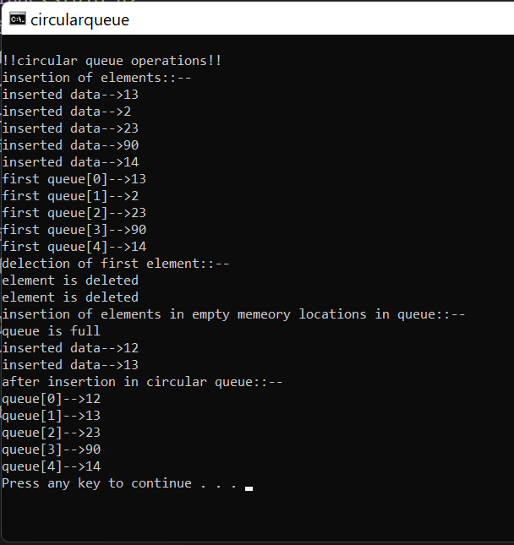

**PROBLEM FACED: -**

1. While writing algorithm I faced some problem.
2. While compile time few issues with function word terminology.
3. While runtime I faced issue in minimizing the run time.
4. Failed in collecting deleting elements to another array.
5. Failed in displaying deleted element.
6. Problems with indentation.

**CONCLUSION: -**

1. This experiment helped me to know where my skills are.
2. Learned circular queue concept and using of it.
3. Learned writing code with good indentation.
4. Learned implementation of conditions for if cases properly.
5. This experiment helped me to improve my minimum coding speed.
6. Learned managing memory reusability and management of memory.

**Lab Experiment number: - 04**

**Experiment Topic**: **- Create a singly linked list and perform the following operations:**

a. Add an element at the end of the list

b. Delete an element from the beginning of the list

c. Find the middle element of the list

**AIM: -** Implementation of c code to perform operations on singly linked list data structure like Adding an element at the end of the list, deleting an element from the beginning of the list Finding the middle element of the list Search the given key form the list

**OBJECTIVES: -** By the end of this, we will be able to know how

1. write efficient algorithm to linked list operations.
2. Use structures in singly linked list.
3. Concept of linked list and its operations performs in a code.
4. Improves coding experience.
5. Memory management in linked list data structure.

**CONDITIONS: -**

Conditions to follow while writing code for experiment 04: -

1. Pointers should be named different.
2. Two pointers must be used.
3. Basic mathematical tricks should be used.
4. Memory management should be done.
5. Reusability of empty memory locations present in linked list.
6. All conditions of linked list should be satisfied by this experiment.
7. Initialization of function should be done in header file. (choice)

**ALGORITHM: -**

**Algorithm for insertAtbeginning(struct node** head_reg, int new_data)**

Step 1: - start

Step 2: -allocate memory to a structure variable

Step 3: -new_node🡪data 🡨 new_data

Step 4: -new_node🡪next🡨 head_ref

Step 5: -head_ref🡨new_node

Step 6: -stop

**Algorithm for deleteNode(struct node** head_ref, int key): -**

Step 1: -start

Step 2: - allocate memory to structure variable

Step 3: -if temp! =NULL and temp🡪data==key

Step 4: - prev =temp

Step 5: -temp🡪next

Step 6: -free space

Step 7: -stop

**Algorithm for searchNode(struct node** head_ref, int key): -**

Step 1: -start

Step 2: -check if current is not equal to NULL

Step 3: -if yes then check current🡪data==key

Step 4: -return 1

Step 5: -current🡪next

Step 6: - stop

**Algorithm for LinkedList(struct node** head_ref): -**

Step 1: -start

Step 2: -allocate memory for struct variable

Step 3: -head_ref==NULL

Step 4: -index =current🡪next

Step 5: -index!=NULL

Step 6: -temp 🡪current->data

Step 7: -index =index🡪next

Step 8: - stop

**PROGRAM**: -

**Folder name:** data structures lab

**C File name: -**linkedlistexperiment4.c

**Header file name:** none

**Google drive link:** <https://drive.google.com/file/d/1iRaBvBC58B3x5rwcqNUyNX778IwM8gjv/view?usp=sharing>

**Implementation: -**

/*

Name: -V D Pandurangasai Guptha

Sec:B

Experiment no: -04<A<B<C<D

topic:Linked list

*/

#include <stdio.h>

#include <stdlib.h>

struct node// Create a node

{

int data;

struct node* next;

};

void insertAtBeginning(struct node** head_ref, int new_data) // Insert at the beginning

{

struct node* new_node = (struct node*)malloc(sizeof(struct node));// Allocate memory to a node

new_node->data = new_data;// insert the data

new_node->next = (*head_ref);

(*head_ref) = new_node;// index points to the node next to current

}

// Insert a node after a node

void insertAfter(struct node* prev_node, int new_data)

{

if (prev_node == NULL)

{

printf("the given previous node cannot be NULL");

return;

}

struct node* new_node = (struct node*)malloc(sizeof(struct node));//memory allocation to pointer

new_node->data = new_data; //rearangement

new_node->next = prev_node->next;

prev_node->next = new_node;

}

// Insert the the end

void insertAtEnd(struct node** head_ref, int new_data) {

struct node* new_node = (struct node*)malloc(sizeof(struct node));

struct node* last = *head_ref; /* used in step 5*/

new_node->data = new_data;

new_node->next = NULL;

if (*head_ref == NULL)

{

*head_ref = new_node;

return;

}

while (last->next != NULL) last = last->next;

last->next = new_node;

return;

}

// Delete a node

void deleteNode(struct node** head_ref, int key)

{

struct node *temp = *head_ref, *prev;

if (temp != NULL && temp->data == key)

{

*head_ref = temp->next;

free(temp);

return;

}

// Find the key to be deleted

while (temp != NULL && temp->data != key)

{

prev = temp;

temp = temp->next;

}

// If the key is not present

if (temp == NULL) return;

// Remove the node

prev->next = temp->next;

free(temp);

}

// Search a node

int searchNode(struct node** head_ref, int key)

{

struct node* current = *head_ref;

while (current != NULL)

{

if (current->data == key) return 1;

current = current->next;

}

return 0;

}

// Sort the linked list

void LinkedList(struct node** head_ref)

{

struct node *current = *head_ref, *index = NULL;

int temp;

if (head_ref == NULL)

{

return;

} else {

while (current != NULL)// index points to the node next to current

{

index = current->next;

while (index != NULL)

{

if (current->data > index->data)

{

temp = current->data;

current->data = index->data;

index->data = temp;

}

index = index->next;

}

current = current->next;

}

}

}

// Print the linked list

void printList(struct node* node)

{

while (node != NULL)

{

printf(" %d ", node->data);

node = node->next;

}

}

// Driver program

int main()

{

struct node* head = NULL;

insertAtEnd(&head, 1);

insertAtBeginning(&head, 2);

insertAtBeginning(&head, 3);

insertAtEnd(&head, 4);

insertAfter(head->next, 5);

printf("Linked list: ");

printList(head);

printf("\nAfter deleting an element: ");

deleteNode(&head, 3);

printList(head);

int item_to_find = 3;

if (searchNode(&head, item_to_find))

{

printf("\n%d is found", item_to_find);

} else

{

printf("\n%d is not found", item_to_find);

}

LinkedList(&head);

printf("\nlinked List: ");

printList(head);

}

**Output: -**

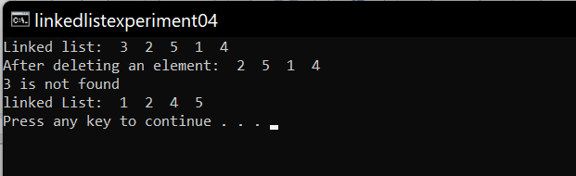

**PROBLEM FACED: -**

1. While writing algorithm I faced some problem.
2. While compile time few issues with function word terminology.
3. While runtime I faced issue in minimizing the run time.
4. Confused while creating pointers.
5. Problems with indentation.

**CONCLUSION: -**

1. This experiment helped me to know where my skills are.
2. Learned linked list concept and using of it.
3. Learned writing code with good indentation.
4. Learned implementation of conditions for a while and for loops properly.
5. This experiment helped me to improve my minimum coding speed.
6. Learned managing memory reusability and management of memory.
7. Learned how to use pointers efficiently.

**Lab Experiment number: - 04B**

**Experiment Topic**: **-**

**e. Priority queue singly linked list.**

**f. Polynomial addition using linked list**

**g. Sparse matrix operations using linked list**

**AIM: -** Implementation of c code to perform operations on priority queue singly linked list and data structure like Adding an element at the end of the list, deleting an element from the beginning of the list Finding the middle element of the list Search the given key form the list and experiment on polynomial addition used linked list and operations on sparse matrix operations using linked list.

**OBJECTIVES: -** By the end of this, we will be able to know how

1. write efficient algorithm to priority and polynomial and sparse matric linked list operations.
2. Use structures in priority and polynomial and sparse matrix singly linked list.
3. Concept of linked list and its operations performs in a code.
4. Improves coding experience.
5. Memory management in linked list data structure.

**CONDITIONS: -**

Conditions to follow while writing code for experiment 04**B**: -

1. Pointers should be named different.
2. Two pointers must be used.
3. Basic mathematical tricks should be used.
4. Management on [polynomial and sparse matrix concepts.
5. Memory management should be done.
6. Reusability of empty memory locations present in linked list.
7. All conditions of linked list should be satisfied by this experiment.
8. Initialization of function should be done in header file. (choice)

**Priority queue singly linked list program**: -

**Folder name:** data structures lab

**C File name: -**experiment.E.c

**Header file name:**

**Google drive link: -**[https://drive.google.com/file/d/1X7umA6BLymS0pCvVyNAdYih6rLwS0p_C/view?usp=sharing](C:\\Users\\pandu\\AppData\\Roaming\\Microsoft\\Word\\experiments.c)

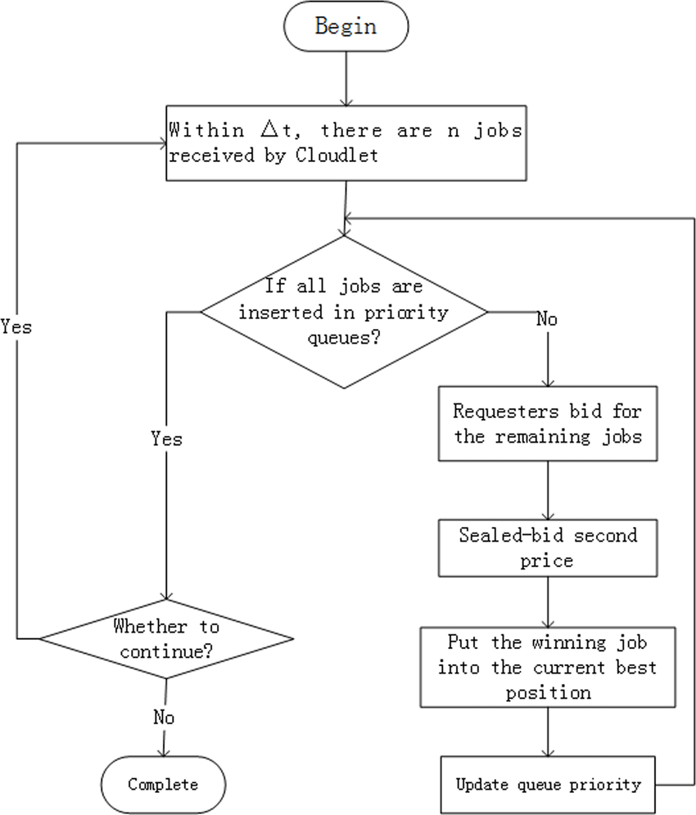**Flow chart: -**

**Implementation: -**

/*

Name: - V D Panduranga Sai Guptha

sec: - B

assignment: -04B

Experiment topic: - Priority queue singly linked list.

*/

#include <stdio.h>

#include <stdlib.h>// header file

// priority Node

typedef struct node {

int data;

int priority; //priority file

struct node* next;

} Node;

Node* newNode(int d, int p) { //function to link new noder o the priority linked list

Node* temp = (Node*)malloc(sizeof(Node));// Temp node

temp->data = d;

temp->priority = p; //temp node family members

temp->next = NULL;

return temp; //returningthe temp node tho the function

}

int peek(Node** head) { //function to check the first element in the priority linked list

return (*head)->data;

}

void pop(Node** head) {

Node* temp = *head;

(*head) = (*head)->next; //condition for making the priority linked list

free(temp); //free the the memory in the heap location

}

void push(Node** head, int d, int p) { //function to push the element into the linke list

Node* start = (*head);

Node* temp = newNode(d, p);

if ((*head)->priority > p) {// condtion to add rhe element to the singly priority linked list

temp->next = *head;

(*head) = temp;

} else {

while (start->next != NULL &&

start->next->priority < p) {

start = start->next;

}

// Either at the ends of the list

// or at required position

temp->next = start->next;

start->next = temp;

}

}

// Function to check the queue is empty

int isEmpty(Node** head) {

return (*head) == NULL;

}

// main function

int main() {

Node* pq = newNode(7, 1);

push(&pq, 1, 2);

push(&pq, 3, 3); //calling thre function

push(&pq, 2, 0); //callintg the function

while (!isEmpty(&pq)) {

printf("%d ", peek(&pq));

pop(&pq);

}

return 0; //returning program to 0

}

**Output: -**

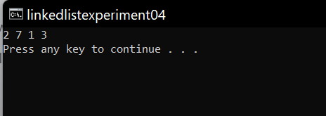

**PROBLEM FACED: -**

1. While writing algorithm I faced some problem.
2. While compile time few issues with function word terminology.
3. While runtime I faced issue in minimizing the run time.
4. Confused while creating pointers.
5. Fee the allocated memory perfectly.
6. Problems with indentation.

**CONCLUSION: -**

1. This experiment helped me to know where my skills are.
2. Learned priority linked list concept and using of it.
3. Learned writing code with good indentation.
4. Learned implementation of conditions for a while and for loops properly.
5. This experiment helped me to improve my minimum coding speed.
6. Learned managing memory reusability and management of memory.
7. Learned how to use pointers efficiently.

**Polynomial addition using linked list experiment: -**

Step 1: loop around all values of linked list and follow step 2& 3.

Step 2: if the value of a node’s exponent. is greater copy this node to result node and head towards the next node.

Step 3: if the values of both node’s exponent is same adding the coefficients and then copy the added value with node to the result.

Step 4: Print the resultant node.

**Implementation: -**

**#include <stdio.h>**

**#include <stdlib.h>**

**/* structure to store data */**

**struct node {**

**int row, col, val;**

**struct node *right, *down;**

**};**

**/* structure of column head */**

**struct chead {**

**int col;**

**struct chead *next;**

**struct node *down;**

**};**

**/* structure of row head */**

**struct rhead {**

**int row;**

**struct rhead *next;**

**struct node *right;**

**};**

**/* structure of additional head */**

**struct sparsehead {**

**int rowCount, colCount;**

**struct rhead *frow;**

**struct chead *fcol;**

**};**

**/* main node */**

**struct sparse {**

**int row, *data;**

**struct node *nodePtr;**

**struct sparsehead *smatrix;**

**struct rhead **rowPtr;**

**struct chead **colPtr;**

**};**

**int count = 0;**

**/* Establish row and column links */**

**void initialize(struct sparse *sPtr, int row, int col) {**

**int i;**

**sPtr->rowPtr = (struct rhead **) calloc(1, (sizeof (struct rhead) * row));**

**sPtr->colPtr = (struct chead **) calloc(1, (sizeof (struct chead) * col));**

**for (i = 0; i < row; i++)**

**sPtr->rowPtr[i] = (struct rhead *) calloc(1, sizeof (struct rhead));**

**for (i = 0; i < row - 1; i++) {**

**sPtr->rowPtr[i]->row = i;**

**sPtr->rowPtr[i]->next = sPtr->rowPtr[i + 1];**

**}**

**for (i = 0; i < col; i++)**

**sPtr->colPtr[i] = (struct chead *) calloc(1, sizeof (struct chead));**

**for (i = 0; i < col - 1; i++) {**

**sPtr->colPtr[i]->col = i;**

**sPtr->colPtr[i]->next = sPtr->colPtr[i + 1];**

**}**

**/* update additional head information */**

**sPtr->smatrix = (struct sparsehead *) calloc(1, sizeof (struct sparsehead));**

**sPtr->smatrix->rowCount = row;**

**sPtr->smatrix->colCount = col;**

**sPtr->smatrix->frow = sPtr->rowPtr[0];**

**sPtr->smatrix->fcol = sPtr->colPtr[0];**

**return;**

**}**

**/* input sparse matrix */**

**void inputMatrix(struct sparse *sPtr, int row, int col) {**

**int i, n, x = 0, y = 0;**

**n = row * col;**

**sPtr->data = (int *) malloc(sizeof (int) * n);**

**for (i = 0; i < n; i++) {**

**if (y != 0 && y % col == 0) {**

**x++;**

**y = 0;**

**}**

**printf("data[%d][%d] : ", x, y);**

**scanf("%d", &(sPtr->data[i]));**

**if (sPtr->data[i])**

**count++;**

**y++;**

**}**

**return;**

**}**

**/* display sparse matrix */**

**void displayInputMatrix(struct sparse s, int row, int col) {**

**int i;**

**for (i = 0; i < row * col; i++) {**

**if (i % col == 0)**

**printf("\n");**

**printf("%d ", s.data[i]);**

**}**

**printf("\n");**

**return;**

**}**

**/* create 3-tuple array from input sparse matrix */**

**void createThreeTuple(struct sparse *sPtr, struct sparse s, int row, int col) {**

**int i, j = 0, x = 0, y = 0, l = 0;**

**sPtr->row = count;**

**sPtr->data = (int *) malloc(sizeof (int) * (sPtr->row * 3));**

**for (i = 0; i < row * col; i++) {**

**if (y % col == 0 && y != 0) {**

**x++;**

**y = 0;**

**}**

**if (s.data[i] != 0) {**

**sPtr->data[l++] = x;**

**sPtr->data[l++] = y;**

**sPtr->data[l++] = s.data[i];**

**}**

**y++;**

**}**

**return;**

**}**

**/* insert element to the list */**

**void insert(struct sparse *sPtr, int row, int col, int val) {**

**struct rhead *rPtr;**

**struct chead *cPtr;**

**struct node *n1, *n2;**

**struct sparsehead *smat = sPtr->smatrix;**

**int i, j;**

**/* update node values */**

**sPtr->nodePtr = (struct node *) malloc(sizeof (struct node));**

**sPtr->nodePtr->row = row;**

**sPtr->nodePtr->col = col;**

**sPtr->nodePtr->val = val;**

**/* get the row headnode */**

**rPtr = smat->frow;**

**/* move to corresponding row */**

**for (i = 0; i < row; i++)**

**rPtr = rPtr->next;**

**/* traverse the nodes in current and locate new node */**

**n1 = rPtr->right;**

**if (!n1) {**

**rPtr->right = sPtr->nodePtr;**

**sPtr->nodePtr->right = NULL;**

**} else {**

**while (n1 && n1->col < col) {**

**n2 = n1;**

**n1 = n1->right;**

**}**

**n2->right = sPtr->nodePtr;**

**sPtr->nodePtr->right = NULL;**

**}**

**/* get the column head node */**

**cPtr = sPtr->smatrix->fcol;**

**/* move to corresponding column (1/2/3..) */**

**for (i = 0; i < col; i++)**

**cPtr = cPtr->next;**

**/\***

**\* traverse the node in current column and locate**

**\* new node in appropriate position**

**\*/**

**n1 = cPtr->down;**

**if (!n1) {**

**cPtr->down = sPtr->nodePtr;**

**sPtr->nodePtr->down = NULL;**

**} else {**

**while (n1 && n1->row < row) {**

**n2 = n1;**

**n1 = n1->down;**

**}**

**n2->down = sPtr->nodePtr;**

**sPtr->nodePtr->down = NULL;**

**}**

**return;**

**}**

**/* create list for 3-Tuple representation */**

**void createList(struct sparse *sPtr) {**

**int i, j = 0;**

**for (i = 0; i < sPtr->row; i++) {**

**insert(sPtr, sPtr->data[j], sPtr->data[j + 1], sPtr->data[j + 2]);**

**j = j + 3;**

**}**

**return;**

**}**

**/* Display data from linked list of 3-Tuple*/**

**void displayList(struct sparse s) {**

**struct node *n;**

**int row = s.smatrix->rowCount, i;**

**for (i = 0; i < row; i++) {**

**n = s.rowPtr[i]->right;**

**if (n) {**

**while (n->right) {**

**printf("%d %d %d\n", n->row, n->col, n->val);**

**n = n->right;**

**}**

**if (n->row == i) {**

**printf("%d %d %d\n", n->row, n->col, n->val);**

**}**

**}**

**}**

**printf("\n");**

**}**

**int main() {**

**struct sparse input, output;**

**int row, col;**

**printf("Enter the rows and columns:");**

**scanf("%d%d", &row, &col);**

**initialize(&input, row, col);**

**initialize(&output, row, col);**

**inputMatrix(&input, row, col);**

**printf("Given Sparse Matrix has %d non-zero elements\n", count);**

**printf("Input Sparse Matrix:\n");**

**displayInputMatrix(input, row, col);**

**printf("\n\n");**

**createThreeTuple(&output, input, row, col);**

**createList(&output);**

**printf("3-Tuple representation of the given sparse matrix:\n");**

**printf("%d %d %d\n", output.smatrix[0].rowCount,**

**output.smatrix[0].colCount, count);**

**displayList(output);**

**return 0;**

**}**

**Output: -**

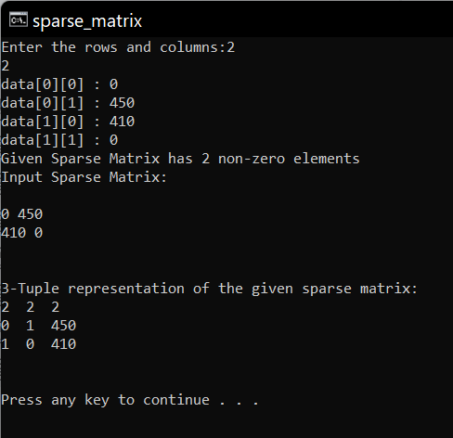

**PROBLEMS FACED**

visualizing and doing this problem is hard but doing many times it was easy .

**CONCLUSION**

By doing this assignment I got to learn about 1.)Sparse matrix operations using linked list

**Lab Experiment number: - 05**

**Experiment Topic**: - **operations on trees**

**AIM: -** Implementation of C language code to execute the program to run operations on trees data structures

**OBJECTIVES: -** By the end of this assignment, we will be able to

1. write efficient algorithm to a specific problem.
2. Use dynamic memory allocation.
3. Concept of trees and operations.

**CONDITIONS: -**

Conditions to follow while writing code for experiment 05: -

1. Pointers should be named different.
2. Code should have compile time inputs.
3. Memory allocation should be done carefully (structure data type).
4. Maintain less runtime.
5. Operations with perfect function name.

**ALGORITHM: -**

**Inorder function algorithm: -**

**Step1: -**Traverse the left subtree call Inorder

**Step2: -** Visit the root.

**Step3: -**Traverse the right subtree call Inorder

**Preorder function algorithm: -**

**Step1: -** Visit the root.

**Step2: -** Traverse the left subtree call Preorder

**Step3: -** Traverse the right subtree call Preorder

**Postorder function algorithm: -**

**Step1: -**Traverse the left subtree call Postorder

**Step2: -**Traverse the right subtree call Postorder-subtree)

3. Visit the root.

**PROGRAM**: -

**File name: -**trees

**Google drive link:** <https://drive.google.com/file/d/1mxK92JNQrdUzp8HH-lcXO-sWAaFaosz0/view?usp=sharing>

**Implementation: -**

**/\***

**Name: -V D Panduranga Sai Guptha**

**Sect: -B**

**Topic: -Implementation of Binary tree traversals techniques:**

**a. pre-order**

**b. in-order, and**

**c. post-order.**

**\*/**

**#include <stdio.h>**

**#include <stdlib.h> //standard library**

**struct node { //structure to acess the node**

**int data;**

**struct node* left;**

**struct node* right;**

**};**

**struct node* newNode(int data)//function to create new node**

**{**

**struct node* node**

**= (struct node*)malloc(sizeof(struct node));//memory allocation**

**node->data = data; //condition**

**node->left = NULL;//condition**

**node->right = NULL;//condition**

**return (node); //returning node**

**}**

**void printPostorder(struct node* node)//function to print the post order of trees**

**{**

**if (node == NULL)**

**return;**

**printPostorder(node->left);//recurive tool**

**printPostorder(node->right);**

**printf("%d ", node->data);**

**}**

**void printInorder(struct node* node)//function to print inorder of the tree datastructure**

**{**

**if (node == NULL)**

**return;**

**printInorder(node->left);**

**printf("%d ", node->data);**

**printInorder(node->right);//calling the printinorder function**

**}**

**void printPreorder(struct node* node)//function to print the preorder of the trees**

**{**

**if (node == NULL)**

**return;**

**printf("%d ", node->data);**

**printPreorder(node->left);**

**printPreorder(node->right);//calling the function into the function**

**}**

**int main()**

**{**

**struct node* root = newNode(1);//declaration of ther variable of the type oof the node**

**root->left = newNode(2);//condition**

**root->right = newNode(3); //condition**

**root->left->left = newNode(4);**

**root->left->right = newNode(5);**

**printf("\nPreorder traversal of binary tree is \n");**

**printPreorder(root);//parameter tof the function**

**printf("\nInorder traversal of binary tree is \n");**

**printInorder(root);**

**printf("\nPostorder traversal of binary tree is \n");**

**printPostorder(root);**

**return 0;**

**}**

**Output: -**

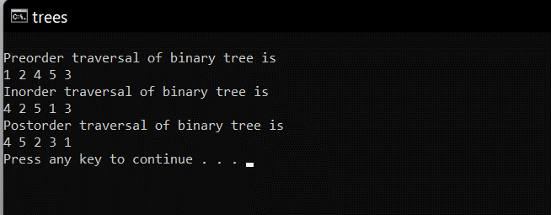

**PROBLEM FACED: -**

1. While writing algorithm I faced some problem.
2. While compile time few issues with function word terminology.
3. While runtime I faced issue in minimizing the run time.
4. Failed in displaying deleted element.
5. Problems with indentation.

**CONCLUSION: -**

1. This experiment helped me to know where my skills are.
2. Learned trees concept and using of it.
3. Learned writing code with good indentation.
4. Learned implementation of conditions for if cases properly.
5. This experiment helped me to improve my minimum coding speed.
6. Learned managing memory reusability and management of memory.

**Lab Experiment number: - 06**

**Experiment Topic**: -implementation of AVL tree and its operations

a. Insertion

b. Deletion

c. Traversing

**AIM: -** Implementation of c code to perform operations on AVL Trees structure like inserting elements to AVL Trees and deleting the elements from Trees and printing the pre_order and post order.

**OBJECTIVES: -** By the end of this, we will be able to know how

1. write efficient algorithm to linear AVL Trees operations.
2. Use structures and pointers in data structures.
3. Concept of AVL trees and its operations performs in a code.
4. Improves coding experience.

**CONDITIONS: -**

Conditions to follow while writing code for experiment 03A: -

1. Structures🡪variables should be named different.
2. Third pointers must be used.
3. Basic mathematical tricks should be used.
4. Memory management should be done.
5. All conditions of AVL trees should be satisfied by this experiment.
6. Initialization of function should be done in header file. (choice)

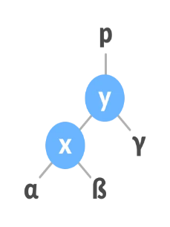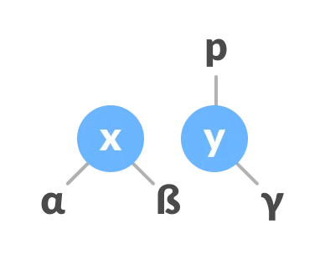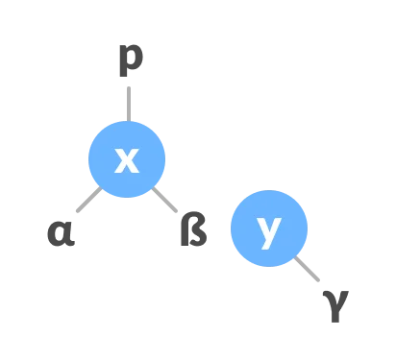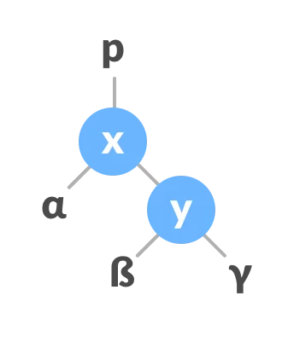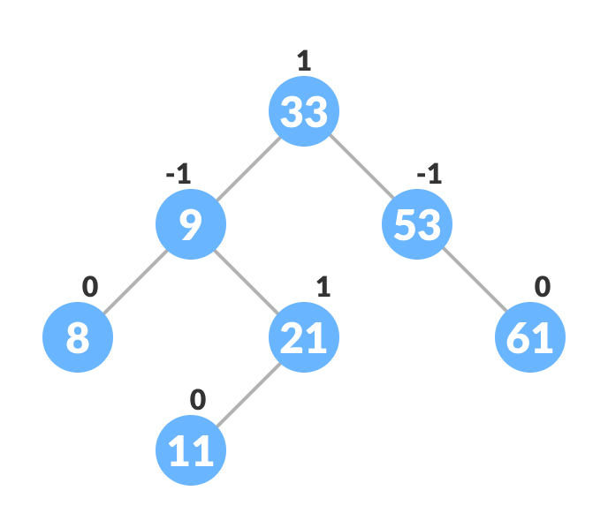**ALGORITHM: -**

**PROGRAM**: -

**C File name: -**avl.c

**Google drive link:** <https://drive.google.com/file/d/1uFAU29UBglD6xV__UoOpzcsBT288NEBe/view?usp=sharing>

**Implementation: -**

**Avl.c**

/*

Name:-V D pandurangasai Guptha

section :- B

lab_program:-06

*/

#include <stdio.h>

#include <stdlib.h>

struct Node // structure node to avl tree

{

int key; //

struct Node *left;//

struct Node *right;// members of the avl tree (parameters)

int height;//

};

int max(int a, int b); //unction to find it fmax height of tree

int height(struct Node *N) {

if (N == NULL)

return 0;

return N->height;

}

int max(int a, int b) {

return (a > b) ? a : b;

}

struct Node *newNode(int key) { //function to create the new node to the avl tree

struct Node *node = (struct Node *)

malloc(sizeof(struct Node)); //dynamic memory allocations

node->key = key;

node->left = NULL;

node->right = NULL;

node->height = 1;

return (node);

}

struct Node *rightRotate(struct Node *y) {

struct Node *x = y->left;

struct Node *T2 = x->right;

x->right = y;

y->left = T2;

y->height = max(height(y->left), height(y->right)) + 1;

x->height = max(height(x->left), height(x->right)) + 1;

return x;

}

// Left rotate

struct Node *leftRotate(struct Node *x) {

struct Node *y = x->right;

struct Node *T2 = y->left;

y->left = x;

x->right = T2;

x->height = max(height(x->left), height(x->right)) + 1;

y->height = max(height(y->left), height(y->right)) + 1;

return y;

}

// Get the balance factor

int getBalance(struct Node *N) {

if (N == NULL)

return 0;

return height(N->left) - height(N->right);

}

// Insert node

struct Node *insertNode(struct Node *node, int key) {

// Find the correct position to insertNode the node and insertNode it

if (node == NULL)

return (newNode(key));

if (key < node->key)

node->left = insertNode(node->left, key);

else if (key > node->key)

node->right = insertNode(node->right, key);

else

return node;

// Update the balance factor of each node and

// Balance the tree

node->height = 1 + max(height(node->left),

height(node->right));

int balance = getBalance(node);

if (balance > 1 && key < node->left->key)

return rightRotate(node);

if (balance < -1 && key > node->right->key)

return leftRotate(node);

if (balance > 1 && key > node->left->key) {

node->left = leftRotate(node->left);

return rightRotate(node);

}

if (balance < -1 && key < node->right->key) {

node->right = rightRotate(node->right);

return leftRotate(node);

}

return node;

}

struct Node *minValueNode(struct Node *node) {

struct Node *current = node;

while (current->left != NULL)

current = current->left;

return current;

}

// Delete a nodes

struct Node *deleteNode(struct Node *root, int key) {

// Find the node and delete it

if (root == NULL)

return root;

if (key < root->key)

root->left = deleteNode(root->left, key);

else if (key > root->key)

root->right = deleteNode(root->right, key);

else {

if ((root->left == NULL) || (root->right == NULL)) {

struct Node *temp = root->left ? root->left : root->right;

if (temp == NULL) {

temp = root;

root = NULL;

} else

*root = *temp;

free(temp);

} else {

struct Node *temp = minValueNode(root->right);

root->key = temp->key;

root->right = deleteNode(root->right, temp->key);

}

}

if (root == NULL)

return root;

// Update the balance factor of each node and

// balance the tree

root->height = 1 + max(height(root->left),

height(root->right));

int balance = getBalance(root);

if (balance > 1 && getBalance(root->left) >= 0)

return rightRotate(root);

if (balance > 1 && getBalance(root->left) < 0) {

root->left = leftRotate(root->left);

return rightRotate(root);

}

if (balance < -1 && getBalance(root->right) <= 0)

return leftRotate(root);

if (balance < -1 && getBalance(root->right) > 0) {

root->right = rightRotate(root->right);

return leftRotate(root);

}

return root;

}

// Print the tree

void printPreOrder(struct Node *root) {

if (root != NULL) {

printf("%d ", root->key);

printPreOrder(root->left);

printPreOrder(root->right);

}

}

int main() {

struct Node *root = NULL;

root = insertNode(root, 2);

root = insertNode(root, 1);

root = insertNode(root, 7);

root = insertNode(root, 4);

root = insertNode(root, 5);

root = insertNode(root, 3);

root = insertNode(root, 8);

printPreOrder(root);

root = deleteNode(root, 3);

printf("\nAfter deletion: ");

printPreOrder(root);

return 0;

}

**OUTPUT: -**

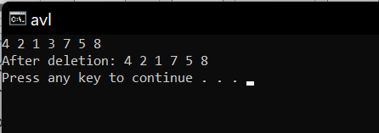

**PROBLEM FACED: -**

1. While writing algorithm I faced some problem.
2. While compile time few issues with function word terminology.
3. While runtime I faced issue in minimizing the run time.
4. theoretical mistakes.
5. Problems with indentation.

**CONCLUSION: -**

1. This experiment helped me to know where my skills are.
2. Learned AVL trees concept and using of it.
3. Learned writing code with good indentation.
4. Learned implementation of conditions for if cases properly.
5. This experiment helped me to improve my minimum coding speed.
6. Learned managing memory reusability and management of memory.

**Lab Experiment number: - 07**

**Experiment Topic**: -implementation of BFS and DFS tree and its operations and implementation of algorithm.

**AIM: -** Implementation of c code

Breadth first search Algorithm

A standard BFS implementation puts each vertex of the graph into one of two categories:

Visited

Not Visited

Implementation of c code

Depth First Search Algorithm

A standard DFS implementation puts each vertex of the graph into one of two categories:

Visited

Not Visited

**OBJECTIVES: -** By the end of this, we will be able to know how

1. write efficient algorithm to bfs and dfs.
2. Use structures and pointers in data structures.
3. Concept of BFS and DFS.
4. Improves coding experience.

**ALGORITHM:**

**PROGRAM**: -

**C File name: -**dfs_bfs.c

**Google drive link:** <https://drive.google.com/file/d/1uFAU29UBglD6xV__UoOpzcsBT288NEBe/view?usp=sharing>

// BFS algorithm in C

#include <stdio.h>

#include <stdlib.h>

#define SIZE 40

struct queue {

int items[SIZE];

int front;

int rear;

};

struct queue* createQueue();

void enqueue(struct queue* q, int);

int dequeue(struct queue* q);

void display(struct queue* q);

int isEmpty(struct queue* q);

void printQueue(struct queue* q);

struct node {

int vertex;

struct node* next;

};

struct node* createNode(int);

struct Graph {

int numVertices;

struct node** adjLists;

int* visited;

};

// BFS algorithm

void bfs(struct Graph* graph, int startVertex) {

struct queue* q = createQueue()

graph->visited[startVertex] = 1;

enqueue(q, startVertex);

while (!isEmpty(q)) {

printQueue(q);

int currentVertex = dequeue(q);

printf("Visited %d\n", currentVertex);

struct node* temp = graph->adjLists[currentVertex];

while (temp) {

int adjVertex = temp->vertex;

if (graph->visited[adjVertex] == 0) {

graph->visited[adjVertex] = 1;

enqueue(q, adjVertex);

}

temp = temp->next;

}

}

}

// Creating a node

struct node* createNode(int v) {

struct node* newNode = malloc(sizeof(struct node));

newNode->vertex = v;

newNode->next = NULL;

return newNode;

}

// Creating a graph

struct Graph* createGraph(int vertices) {

struct Graph* graph = malloc(sizeof(struct Graph));

graph->numVertices = vertices;

graph->adjLists = malloc(vertices * sizeof(struct node*));

graph->visited = malloc(vertices * sizeof(int));

int i;

for (i = 0; i < vertices; i++) {

graph->adjLists[i] = NULL;

graph->visited[i] = 0;

}

return graph;

}

// Add edge

void addEdge(struct Graph* graph, int src, int dest) {

// Add edge from src to dest

struct node* newNode = createNode(dest);

newNode->next = graph->adjLists[src];

graph->adjLists[src] = newNode;

// Add edge from dest to src

newNode = createNode(src);

newNode->next = graph->adjLists[dest];

graph->adjLists[dest] = newNode;

}

// Create a queue

struct queue* createQueue() {

struct queue* q = malloc(sizeof(struct queue));

q->front = -1;

q->rear = -1;

return q;

}

// Check if the queue is empty

int isEmpty(struct queue* q) {

if (q->rear == -1)

return 1;

else

return 0;

}

// Adding elements into queue

void enqueue(struct queue* q, int value) {

if (q->rear == SIZE - 1)

printf("\nQueue is Full!!");

else {

if (q->front == -1)

q->front = 0;

q->rear++;

q->items[q->rear] = value;

}

}

// Removing elements from queue

int dequeue(struct queue* q) {

int item;

if (isEmpty(q)) {

printf("Queue is empty");

item = -1;

} else {

item = q->items[q->front];

q->front++;

if (q->front > q->rear) {

printf("Resetting queue ");

q->front = q->rear = -1;

}

}

return item;

}

// Print the queue

void printQueue(struct queue* q) {

int i = q->front;

if (isEmpty(q)) {

printf("Queue is empty");

} else {

printf("\nQueue contains \n");

for (i = q->front; i < q->rear + 1; i++) {

printf("%d ", q->items[i]);

}

}

}

int main() {

struct Graph* graph = createGraph(6);

addEdge(graph, 0, 1);

addEdge(graph, 0, 2);

addEdge(graph, 1, 2);

addEdge(graph, 1, 4);

addEdge(graph, 1, 3);

addEdge(graph, 2, 4);

addEdge(graph, 3, 4);

bfs(graph, 0);

return 0;

}

Dfs algorithm:

#include <stdio.h>

#include <stdlib.h>

struct node {

int vertex;

struct node* next;

};

struct node* createNode(int v);

struct Graph {

int numVertices;

int* visited;

// We need int** to store a two dimensional array.

// Similary, we need struct node** to store an array of Linked lists

struct node** adjLists;

};

// DFS algo

void DFS(struct Graph* graph, int vertex) {

struct node* adjList = graph->adjLists[vertex];

struct node* temp = adjList;

graph->visited[vertex] = 1;

printf("Visited %d \n", vertex);

while (temp != NULL) {

int connectedVertex = temp->vertex;

if (graph->visited[connectedVertex] == 0) {

DFS(graph, connectedVertex);

}

temp = temp->next;

}

}

// Create a node

struct node* createNode(int v) {

struct node* newNode = malloc(sizeof(struct node));

newNode->vertex = v;

newNode->next = NULL;

return newNode;

}

// Create graph

struct Graph* createGraph(int vertices) {

struct Graph* graph = malloc(sizeof(struct Graph));

graph->numVertices = vertices;

graph->adjLists = malloc(vertices * sizeof(struct node*));

graph->visited = malloc(vertices * sizeof(int));

int i;

for (i = 0; i < vertices; i++) {

graph->adjLists[i] = NULL;

graph->visited[i] = 0;

}

return graph;

}

// Add edge

void addEdge(struct Graph* graph, int src, int dest) {

// Add edge from src to dest

struct node* newNode = createNode(dest);

newNode->next = graph->adjLists[src];

graph->adjLists[src] = newNode;

// Add edge from dest to src

newNode = createNode(src);

newNode->next = graph->adjLists[dest];

graph->adjLists[dest] = newNode;

}

// Print the graph

void printGraph(struct Graph* graph) {

int v;

for (v = 0; v < graph->numVertices; v++) {

struct node* temp = graph->adjLists[v];

printf("\n Adjacency list of vertex %d\n ", v);

while (temp) {

printf("%d -> ", temp->vertex);

temp = temp->next;

}

printf("\n");

}

}

int main() {

struct Graph* graph = createGraph(4);

addEdge(graph, 0, 1);

addEdge(graph, 0, 2);

addEdge(graph, 1, 2);

addEdge(graph, 2, 3);

printGraph(graph);

DFS(graph, 2);

return 0;

}

**BFS Algorithm Complexity:**

The time complexity of the BFS algorithm is represented in the form of O(V + E), where V is the number of nodes and E is the number of edges.

The space complexity of the algorithm is O(V).

**BFS Algorithm Applications**

To build index by search index

For GPS navigation

Path finding algorithms

In Ford-Fulkerson algorithm to find maximum flow in a network

Cycle detection in an undirected graph

In minimum spanning tree

**Output:**

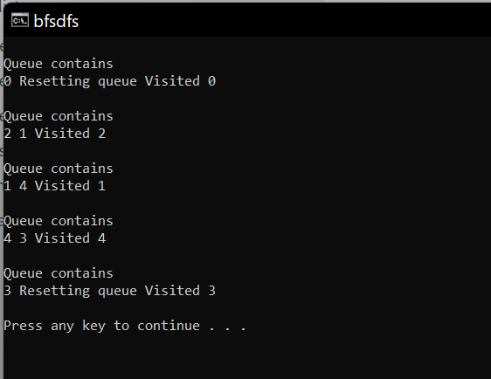

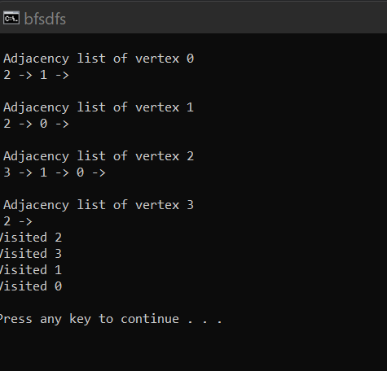

**BFS Algorithm Complexity:**

The time complexity of the BFS algorithm is represented in the form of O(V + E), where V is the number of nodes and E is the number of edges.

The space complexity of the algorithm is O(V).

**BFS Algorithm Applications**

To build index by search index

For GPS navigation

Path finding algorithms

In Ford-Fulkerson algorithm to find maximum flow in a network

Cycle detection in an undirected graph

In minimum spanning tree

**Complexity of Depth First Search**

The time complexity of the DFS algorithm is represented in the form of O(V + E), where V is the number of nodes and E is the number of edges.

The space complexity of the algorithm is O(V).

**Application of DFS Algorithm**

For finding the path

To test if the graph is bipartite

For finding the strongly connected components of a graph

For detecting cycles in a graph